KISII UNIVERSITY INNOVATION CHALLENGE 2021

Name: Andrew Precious Mbugua
Admission number: IN13/00038/19
Course: Computer Science
Year : year 2 sem 2

Github Link (https://github.com/Andrews-Projects/Computer-Vision)

Computer Vision Project – Sign language interpreter

INTRODUCTION

Not everyone understands sign language,this project aims to solve this by removing the need of having a person who understands sign language interpret every single sign.

The project employs the following areas:
1. Computer vision. [OpenCV library]
2. Deep learning. [TensorFlow library]

The project will be implemented in 3 phases:

1. Recognize simple hand poses by tracing the hand’s joints.
2. Implement TensorFlow object detection.
3. Implement Deep learning & train model.

Aim
1. To help the deaf and mute better communicate with the people around them.
2. Attempt to bridge the communication barrier between people with disabilities.

Phase 1: Implement hand pose detection

- Recognize the flow of movement of both hands finding key areas on a hand. Key-points correspond to the joints.

Dependencies & Tools used

-- MediaPipe - MediaPipe is a library that enables object tracking by offering customizable M.L solutions for live and streaming media.

-- OpenCV -an open source framework used for Image and video manipulations.

Screenshots

1st pic - Front palm 2nd pic- Back of hand
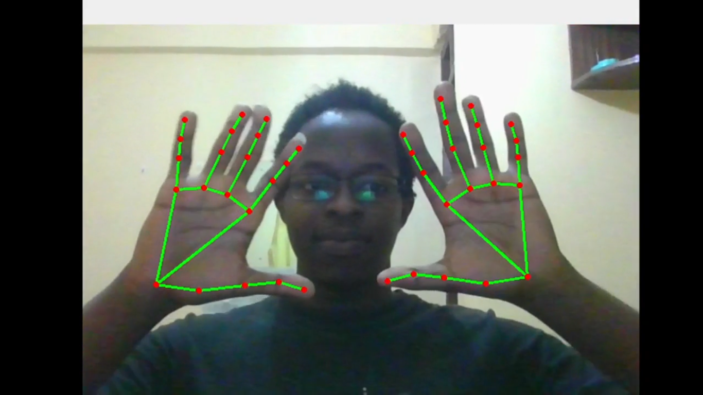
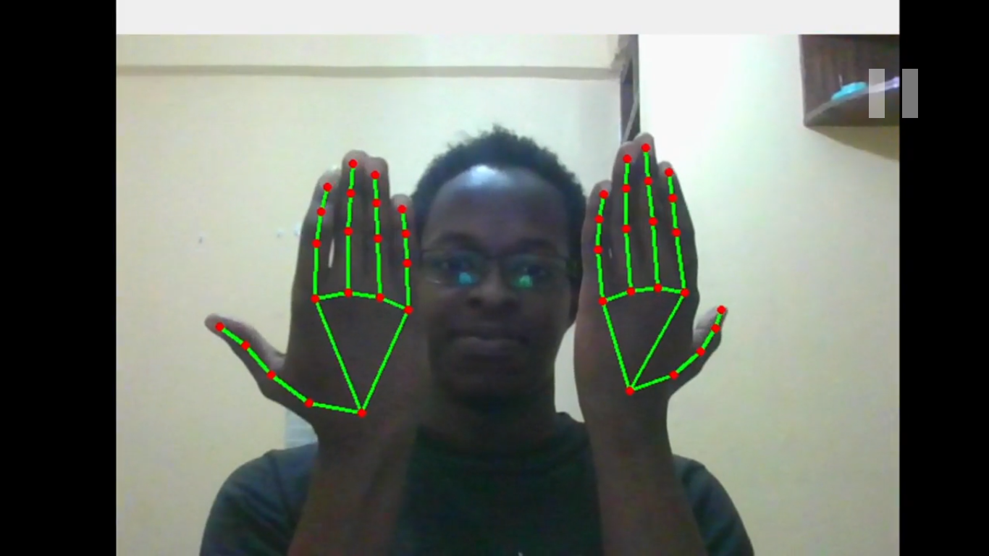

Labelling images preparing them for training using Labelling tool

